Wget https://archive.apache.org/dist/spark/spark-2.0.2/spark-2.0.2-bin-hadoop2.4.tgz
tar xvf spark-2.0.2-bin-hadoop2.4.tgz

mv spark-2.0.2-bin-hadoop2.4.tgz /opt/spark

in .bashrc

#####export the path of spark#####

export SPARK_HOME=/opt/spark
export PATH=$SPARK_HOME/bin:$PATH

Now, we're ready to use pyspark

ls $SPARK_HOME/bin

Spark Shell
===========
There are many other shells which let us manipulate data using the disk and memory on a single machine, however, Spark's shells allow us to interact with data that is distributed on disk or in memory across many machines, and Spark takes care of automatically distributing this processing.In the Spark shell, a special interpreter-aware SparkContext is already created for us, in the variable called sc. So, making our own SparkContext will not work.

Command to enter into spark-shell in scala
>scala
#spark-shell

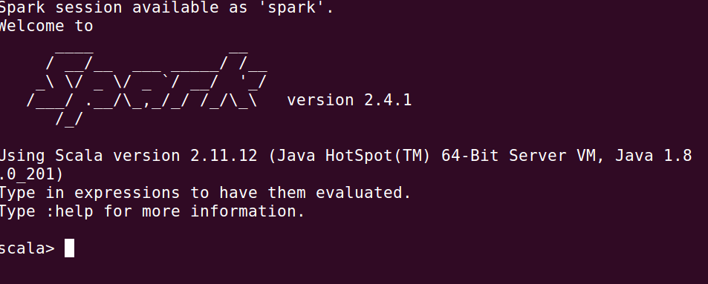

>python

#pyspark
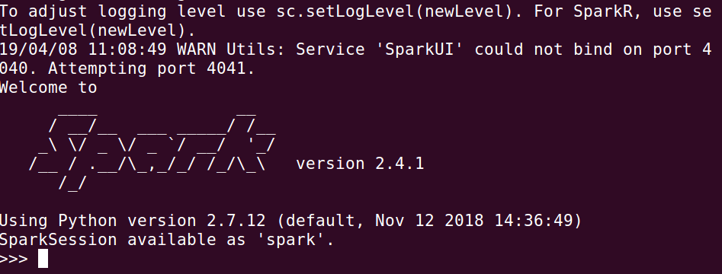

Since Spark can load data into memory on the worker nodes, many distributed computations that process terabytes of data across dozens of nodes, can run in a few seconds. This makes the sort of iterative, ad hoc, and exploratory analysis commonly done in shells a good fit for Spark.

Log using log4j.properties

We can control the verbosity of the logging. To do this, we can create a file, conf/log4j.properties.
Actually, we already have a template for this file called log4j.properties.template. To make the logging less verbose, make a copy of conf/log4j.properties.template and save it as conf/log4j.properties and find the following line:
edit this line as
==================
log4j.rootCategory=INFO, console

log4j.rootCategory=WARN, console

Change INFO as WARN

Using Scala Creating data in spark & parallelizing it

scala> val data = 1 to 20

This will create an resilient distributed dataset (RDD) based on the data. Spark revolves around the concept of the RDD, which is a fault-tolerant collection of elements that can be operated on in parallel.

There are two ways to create RDDs:
- Parallelizing an existing collection in our driver program.
- Referencing a dataset in an external storage system, such as a shared filesystem, HDFS, HBase, or any data source offering a Hadoop InputFormat.

scala> val distData = sc.parallelize(data)

Parallelized collections are created by calling SparkContext's parallelize method on an existing collection in our driver program (a Scala Seq). The elements of the collection are copied to form a distributed dataset that can be operated on in parallel. In our example, we created a parallelized collection holding the numbers 1 to 5.
Once created, the distributed dataset (distData) can be operated on in parallel. For example, we might call distData.reduce((a, b) => a + b) to add up the elements of the array.
One important parameter for parallel collections is the number of partitions to cut the dataset into. Spark will run one task for each partition of the cluster. Typically we want 2-4 partitions for each CPU in our cluster. Normally, Spark tries to set the number of partitions automatically based on our cluster. However, we can also set it manually by passing it as a second parameter to parallelize (e.g. sc.parallelize(data, 10)).

Using scala : filter and map
====================
If we want to get a collection of even numbers, we can use filter():
scala> distData.filter(_ %2 == 0).collect()

We can check the set if each element is even or odd using map():

scala> distData.map(_ %2 == 0).collect()

Using PySpark

As discused earlier, in the PySpark shell, a special interpreter-aware SparkContext is already created for us, in the variable called sc. Therefore, making our own SparkContext will not work.
We can invoke PySpark shell using ./bin/pyspark, and as a review, we'll repeat the previous Scala example using Python.
We'll see two samples: one in this section and the other in next section. The two examples demonstrate two ways of creating RDDs:
- By distributing a collection of objects such as a list or a set in a driver program (the example in this section).
- By loading an external dataset

$ pyspark
>>> data = [1, 2, 3, 4, 5, 6, 7, 8, 9, 10]
>>> distData = sc.parallelize(data)

Let's use filter:

>>> f = distData.filter(lambda x: x % 2 == 0)
>>> f.take(5)
[2, 4]
Now, map:
>>> f = distData.map(lambda x: x % 2 == 0)
>>> f.take(5)
[False, True, False, True, False]

PySpark : Using external dataset
PySpark can create distributed datasets from any storage source supported by Hadoop, including our local file system, HDFS, Cassandra, HBase, Amazon S3, etc. Spark supports text files, SequenceFiles, and any other Hadoop InputFormat.
Text file RDDs can be created using SparkContext's textFile method. This method takes an URI for the file (either a local path on the machine, or a hdfs://, s3n://, etc URI) and reads it as a collection of lines. Here is an example invocation using n input "README.me located in /opt/spark

>>> distFile = sc.textFile("/opt/spark/README.md")

>>> distFile
/opt/spark/README.md MapPartitionsRDD[1] at textFile at NativeMethodAccessorImpl.java:-2
Once created, distFile can be acted on by dataset operations.
Let's see what's in the RDD using the collect() action:
>>> distFile.collect()
When performing collect action on a larger file, the data is pulled from multiples nodes and the driver node might run out of memory. Therefore, the collect action is not recommended on a huge file.

Line count:
>>> distFile.count()
99
To see the content of Spark RDD's, we can use organized format actions such as first() or take().
The first line:
>>> distFile.first()

take(n) returns the first n lines from the dataset and display them on the console:

>>> distFile.take(4)

>> distFile.filter(lambda line: "Spark" in line).count()
19
>>>
>>> distFile.filter(lambda line: "Spark" in line).take(5)
we can add up the sizes of all the lines using the map and reduce operations as follows:
>>> distFile.map(lambda s: len(s)).reduce(lambda a, b: a + b)

PySpark : Saving and Loading SequenceFiles

SequenceFiles can be saved and loaded by specifying the path:
>>> rdd = sc.parallelize(range(1, 10)).map(lambda x: (x, "z" * x ))
>>> rdd.saveAsSequenceFile("./myOutput.txt")
>>> sorted(sc.sequenceFile("./myOutput.txt").collect())
[(1, u'z'), (2, u'zz'), (3, u'zzz'), (4, u'zzzz'), (5, u'zzzzz'), (6, u'zzzzzz'), (7, u'zzzzzzz'), (8, u'zzzzzzzz'), (9, u'zzzzzzzzz')]
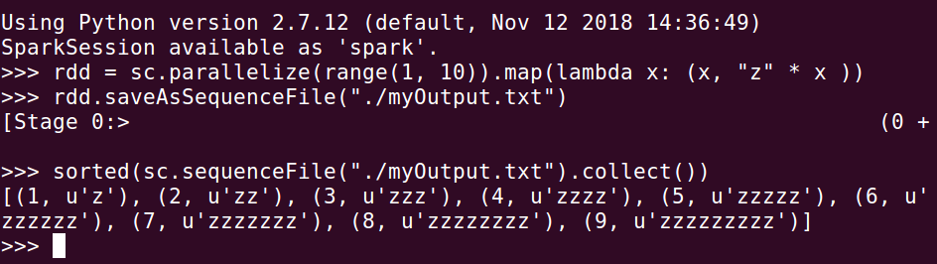

PySparkShell application UI
http://hostname/ip:4040

